Mokuba  Free Lace  allows you to use every fiber we have to create the collage of your dreams. We have free lace paper from Mokuba from our 28 inch wide continuous roll. Just add a sewing machine, water and  voila - Free Lace | 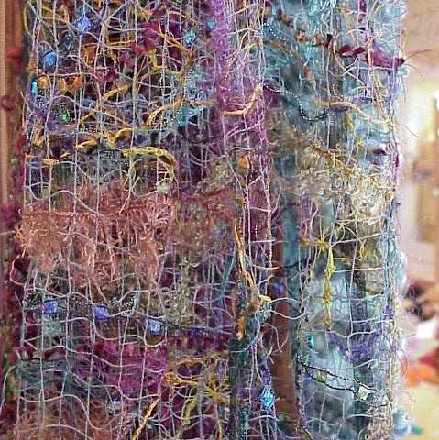
Mokuba Free Lace: $40.32 per yard
Pieces are $0.04/sq inch
An 18" by 28" piece would be $20.16 and will make a 9" by 54" scarf.
Just call Florilegium at 816-746-6164 and order your Free Lace today.
What is Free Lace
The Mokuba Free Lace Sheet has a single sticky side. You lay it out and begin placing yarn, ribbons or other fibers and things in a pattern pleasing to you. When you've finished, place the clear sheet over the sticky one - this gives you a surface to stitch.
Once you've sealed it with a quick hand smoothing over the clear surface, begin stitching. You can stitch everything from an evenly spaced grid, to swirls and zig-zags over the surface using decorative, clear or plain thread. The stitching should touch enough of the fibers to hold the piece together.
You then take the whole thing and place it in room temp water. The sticky stuff and the clear stuff will both dissolve within a minute or so. Continued rinsing for four minutes or so will remove the remaining starchy residue. If you soak less it will keep some body and work well for wall hangings.

